MGT_6203

Swathi

24/06/2022

rm(list=ls())  
library(dplyr)

## Warning: package 'dplyr' was built under R version 4.1.3

##   
## Attaching package: 'dplyr'

## The following objects are masked from 'package:stats':  
##   
## filter, lag

## The following objects are masked from 'package:base':  
##   
## intersect, setdiff, setequal, union

library(ggplot2)

## Warning: package 'ggplot2' was built under R version 4.1.3

set.seed(200)  
germany_datafile<-read.csv("germany-chart.csv")  
head(germany_datafile,4)

## ï..Year Installed.Capacity..MW. Generation..GWÂ.h. Capacity.Factor.in.percent  
## 1 1990 55 71 14.74  
## 2 1991 106 100 10.77  
## 3 1992 174 275 18.04  
## 4 1993 326 600 21.01  
## Capacity.Factor  
## 1 0.1474  
## 2 0.1077  
## 3 0.1804  
## 4 0.2101

colnames(germany_datafile)

## [1] "ï..Year" "Installed.Capacity..MW."   
## [3] "Generation..GWÂ.h." "Capacity.Factor.in.percent"  
## [5] "Capacity.Factor"

germany_datafile <- germany_datafile %>%  
 rename(Year = ï..Year,  
 Installed_Capacity = Installed.Capacity..MW.,  
 Generation = Generation..GWÂ.h.,  
 Capacity_Factor_percent=Capacity.Factor.in.percent,  
 Capacity_Factor=Capacity.Factor)

head(germany_datafile,4)

## Year Installed_Capacity Generation Capacity_Factor_percent Capacity_Factor  
## 1 1990 55 71 14.74 0.1474  
## 2 1991 106 100 10.77 0.1077  
## 3 1992 174 275 18.04 0.1804  
## 4 1993 326 600 21.01 0.2101

linear_model1<-lm(Year~Installed_Capacity,data=germany_datafile)  
summary(linear_model1)

##   
## Call:  
## lm(formula = Year ~ Installed_Capacity, data = germany_datafile)  
##   
## Residuals:  
## Min 1Q Median 3Q Max   
## -5.731 -2.244 1.129 1.711 3.015   
##   
## Coefficients:  
## Estimate Std. Error t value Pr(>|t|)   
## (Intercept) 1.996e+03 6.687e-01 2984.45 <2e-16 ***  
## Installed_Capacity 4.286e-04 2.263e-05 18.94 <2e-16 ***  
## ---  
## Signif. codes: 0 '***' 0.001 '**' 0.01 '*' 0.05 '.' 0.1 ' ' 1  
##   
## Residual standard error: 2.529 on 29 degrees of freedom  
## Multiple R-squared: 0.9252, Adjusted R-squared: 0.9226   
## F-statistic: 358.6 on 1 and 29 DF, p-value: < 2.2e-16

linear_model2<-lm(Year~Generation,data=germany_datafile)  
summary(linear_model2)

##   
## Call:  
## lm(formula = Year ~ Generation, data = germany_datafile)  
##   
## Residuals:  
## Min 1Q Median 3Q Max   
## -7.080 -2.615 1.028 2.327 4.895   
##   
## Coefficients:  
## Estimate Std. Error t value Pr(>|t|)   
## (Intercept) 1.997e+03 8.855e-01 2255.31 < 2e-16 ***  
## Generation 2.135e-04 1.650e-05 12.93 1.44e-13 ***  
## ---  
## Signif. codes: 0 '***' 0.001 '**' 0.01 '*' 0.05 '.' 0.1 ' ' 1  
##   
## Residual standard error: 3.555 on 29 degrees of freedom  
## Multiple R-squared: 0.8522, Adjusted R-squared: 0.8471   
## F-statistic: 167.3 on 1 and 29 DF, p-value: 1.438e-13

p<-ggplot(germany_datafile) + # Create ggplot2 plot  
 geom_line(aes(x=Year,y=Installed_Capacity,color="purple"))+geom_line(aes(x=Year,  
 y=Generation,color="red"))+   
 scale_y_continuous(  
 "Installed_Capacity in MW",   
 sec.axis = sec_axis(~ . *1000, name = "Generated_Power in GWh")  
 )+labs(title="Germany_WindChart")  
p

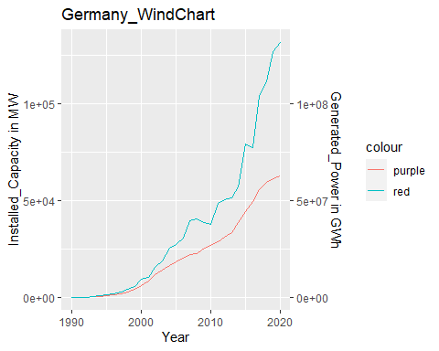

p + scale_color_manual(name="colour",   
 labels = c("MW",   
 "GWh"),   
 values = c("red"="red",   
 "purple"="purple"))

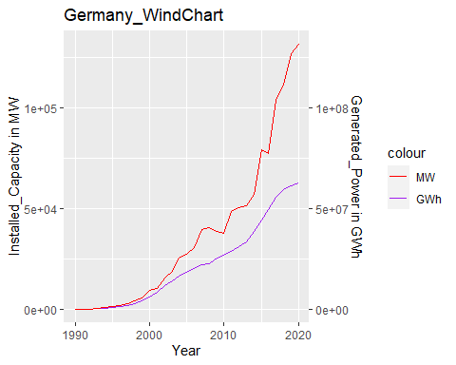 ##not a good graph hence converting variables to logs

log_germany_datafile<-germany_datafile  
log_germany_datafile$log_Installed_Capacity<-log(germany_datafile$Installed_Capacity+1)  
log_germany_datafile$log_Capacity_Factor_percent<-log(germany_datafile$Capacity_Factor+1)  
log_germany_datafile$log_PowerGenerated<-log(germany_datafile$Generation+1)

reg_germany_model_1<-lm(Year~log_Installed_Capacity,data=log_germany_datafile)  
summary(reg_germany_model_1)

##   
## Call:  
## lm(formula = Year ~ log_Installed_Capacity, data = log_germany_datafile)  
##   
## Residuals:  
## Min 1Q Median 3Q Max   
## -4.7444 -2.8900 -0.3938 2.8264 6.3540   
##   
## Coefficients:  
## Estimate Std. Error t value Pr(>|t|)   
## (Intercept) 1967.5962 2.8954 679.57 < 2e-16 ***  
## log_Installed_Capacity 4.1688 0.3151 13.23 8.14e-14 ***  
## ---  
## Signif. codes: 0 '***' 0.001 '**' 0.01 '*' 0.05 '.' 0.1 ' ' 1  
##   
## Residual standard error: 3.486 on 29 degrees of freedom  
## Multiple R-squared: 0.8579, Adjusted R-squared: 0.853   
## F-statistic: 175.1 on 1 and 29 DF, p-value: 8.143e-14

reg_germany_model_2<-lm(Year~log_PowerGenerated,data=log_germany_datafile)  
summary(reg_germany_model_2)

##   
## Call:  
## lm(formula = Year ~ log_PowerGenerated, data = log_germany_datafile)  
##   
## Residuals:  
## Min 1Q Median 3Q Max   
## -4.0875 -2.8330 -0.6193 2.5782 5.5759   
##   
## Coefficients:  
## Estimate Std. Error t value Pr(>|t|)   
## (Intercept) 1967.2362 2.7022 728.00 < 2e-16 ***  
## log_PowerGenerated 4.0190 0.2808 14.31 1.12e-14 ***  
## ---  
## Signif. codes: 0 '***' 0.001 '**' 0.01 '*' 0.05 '.' 0.1 ' ' 1  
##   
## Residual standard error: 3.256 on 29 degrees of freedom  
## Multiple R-squared: 0.876, Adjusted R-squared: 0.8717   
## F-statistic: 204.9 on 1 and 29 DF, p-value: 1.116e-14

plot(reg_germany_model_1)

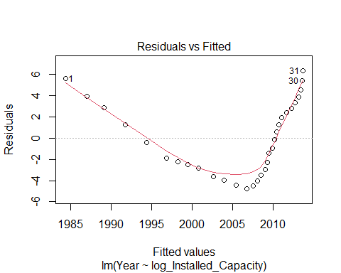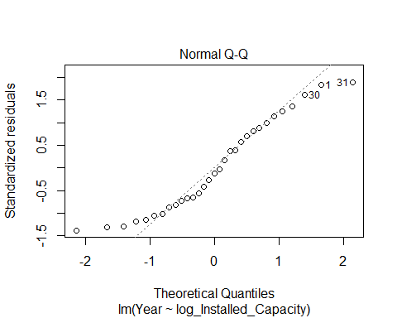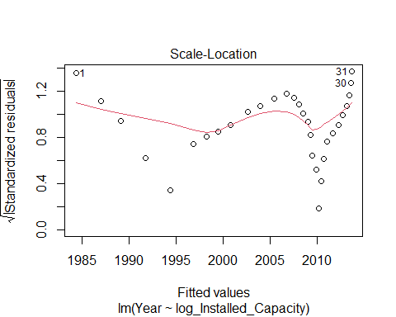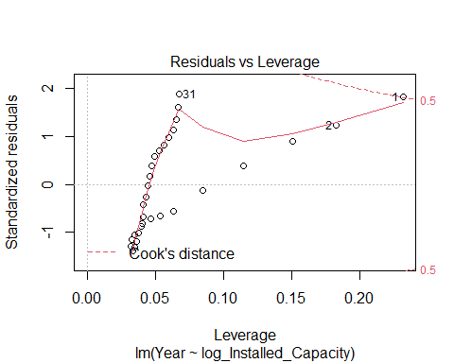

plot(reg_germany_model_2)

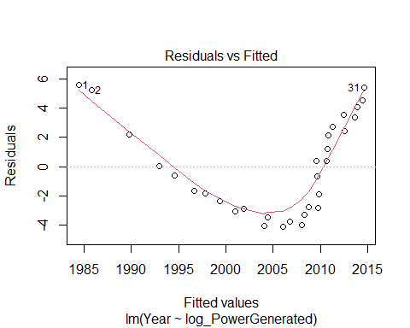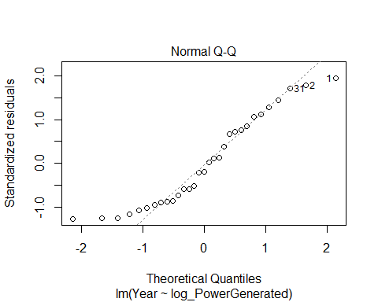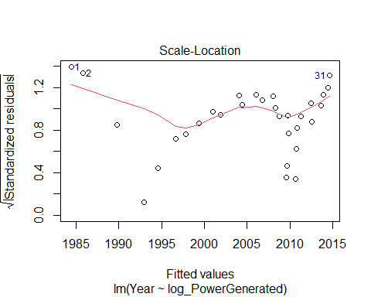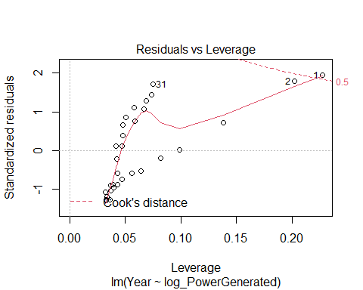

p<-ggplot(log_germany_datafile) + # Create ggplot2 plot  
 geom_line(aes(x=Year,y=log_Installed_Capacity,color="purple"))+geom_line(aes(x=Year,  
 y=log_PowerGenerated,color="red"))+   
 scale_y_continuous(  
 "Installed_Capacity in MW",   
 sec.axis = sec_axis(~ . *1000, name = "Generated_Power in GWh")  
 )+labs(title="Germany_WindChart")  
p

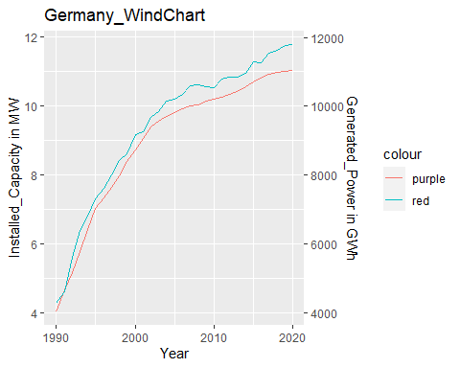

p + scale_color_manual(name="colour",   
 labels = c("MW",   
 "GWh"),   
 values = c("red"="red",   
 "purple"="purple"))

